The following is a presentation of my visualizations and explanations of my analysis of the world dataset statistics.

**Major Correlations –**

1. Birth Rate vs. Fertility Rate (0.96)

* Correlation: Extremely high positive correlation.
* Explanation: Birth rate and fertility rate are closely related metrics. The fertility rate measures the average number of children a woman is expected to have during her lifetime, while the birth rate measures the number of births per 1,000 people per year. Countries with higher fertility rates typically have higher birth rates, which explains this strong correlation.

2. Co2 Emissions vs. GDP (0.92)

* Correlation: Very strong positive correlation.
* Explanation: Generally, as a country's GDP increases, so does its industrial activity and energy consumption, leading to higher CO2 emissions. Wealthier nations tend to have larger industrial sectors and higher energy demands, which contribute to this correlation.

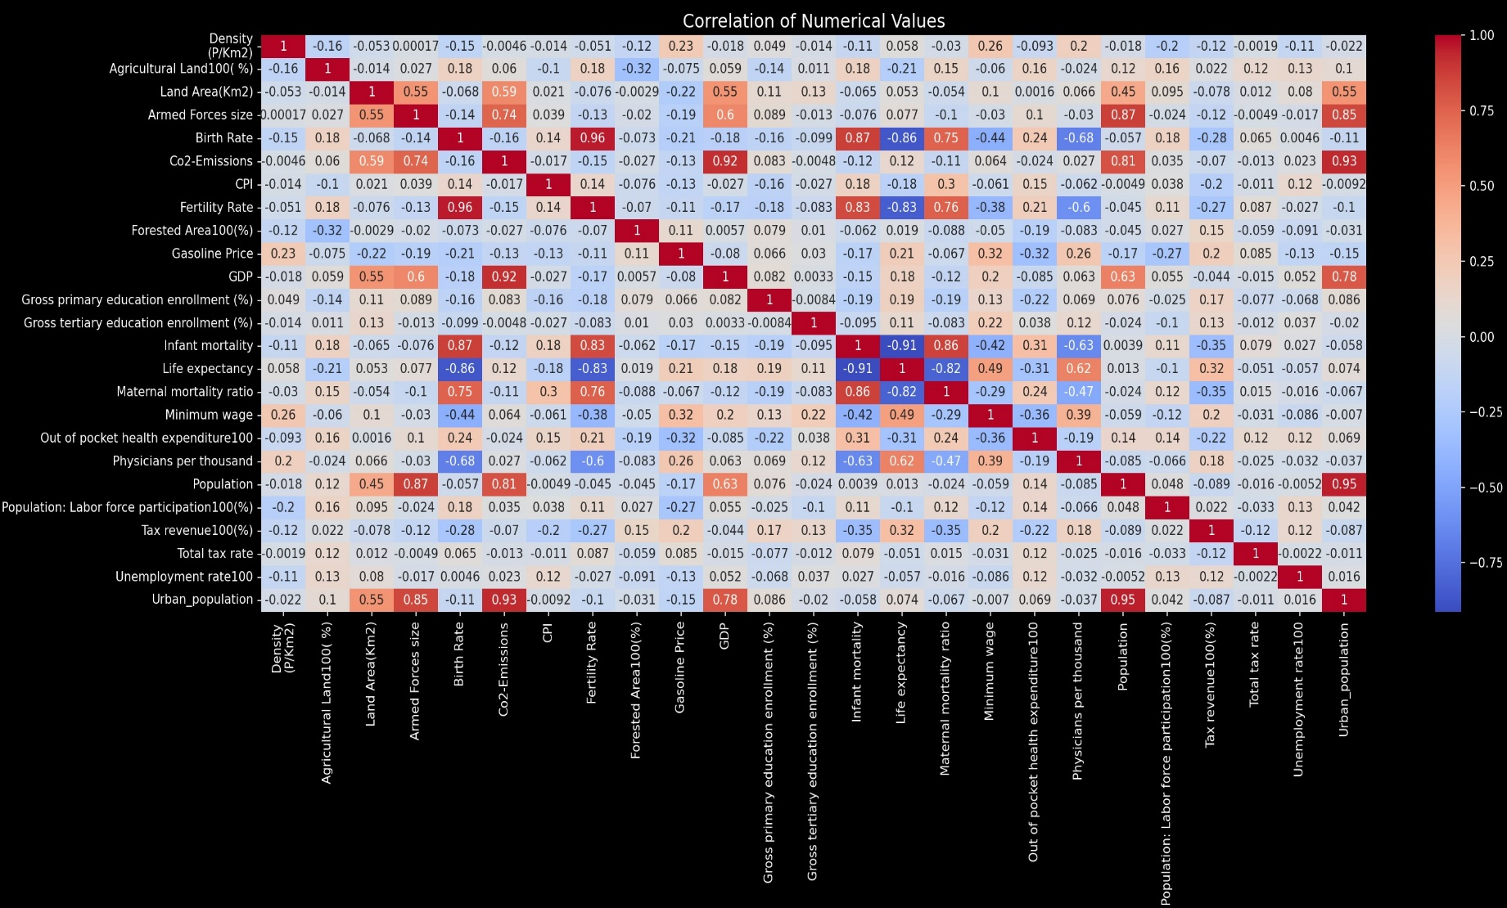

3. Life Expectancy vs. Infant Mortality (-0.91)

* Correlation: Strong negative correlation.
* Explanation: Countries with higher life expectancy typically have better healthcare systems and living conditions, which leads to lower infant mortality rates. The inverse relationship suggests that where infant mortality is low, people tend to live longer due to better healthcare and overall quality of life.

4. Infant Mortality vs. Physicians per Thousand (-0.87)

* Correlation: Strong negative correlation.
* Explanation: Countries with more physicians per thousand people tend to have better healthcare access, which lowers infant mortality rates. A higher density of healthcare providers often correlates with better maternal and infant care, reducing the likelihood of infant deaths.

5. Population vs. Co2 Emissions (0.81)

* Correlation: Strong positive correlation.
* Explanation: More populous countries generally have higher total CO2 emissions because of greater demand for energy, transportation, and industry. This correlation highlights the impact of population size on overall emissions, regardless of per capita emissions.

6. Land Area vs. Armed Forces Size (0.85)

* Correlation: Strong positive correlation.
* Explanation: Larger countries in terms of land area often maintain larger armed forces to defend their extensive borders and manage internal security. The need for a bigger military force in larger countries explains this correlation.

7. GDP vs. Gross Tertiary Education Enrollment (0.78)

* Correlation: Strong positive correlation.
* Explanation: Higher GDP is often associated with better educational systems and more resources to invest in higher education. Wealthier countries typically have higher tertiary (university) enrollment rates due to better infrastructure, access, and funding for education.

8. Urban Population vs. GDP (0.78)

* Correlation: Strong positive correlation.
* Explanation: Urbanization is often linked to economic growth. Cities tend to be centers of economic activity, innovation, and productivity, which contributes to a higher GDP. Countries with higher GDPs generally have more developed urban areas and larger urban populations.

9. Life Expectancy vs. GDP (0.63)

* Correlation: Moderate positive correlation.
* Explanation: Higher GDP allows for better healthcare, nutrition, sanitation, and living conditions, all of which contribute to longer life expectancy. Wealthier nations can invest more in healthcare and social services, leading to better health outcomes and longer lives.

10. Forest Area vs. Co2 Emissions (-0.38)

* Correlation: Moderate negative correlation.
* Explanation: Countries with more forest cover tend to have lower CO2 emissions because forests act as carbon sinks, absorbing CO2 from the atmosphere. Conversely, countries with extensive deforestation or less forested area often see higher CO2 emissions due to less carbon absorption capacity.

These correlations reflect underlying socioeconomic and environmental factors that drive the relationships between different variables. They highlight the interconnected nature of development, health, education, and environmental impact.

**CO2 Emissions: Absolute vs. Per Capita Basis**

**Absolute CO2 Emissions:**

* **Definition:** Absolute CO2 emissions measure the total amount of carbon dioxide emitted by a country as a whole, without considering population size.
* **Usefulness:** This metric is useful for understanding the overall impact of a country on global greenhouse gas levels. Countries with large absolute emissions contribute significantly to global climate change.
* **Example:** China, with its large industrial base and energy consumption, has the highest absolute CO2 emissions in the world.

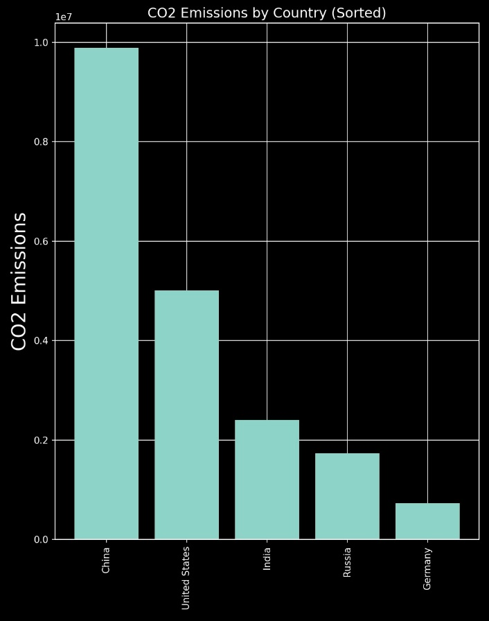

**The Case of China vs. USA**

**Why China Has Higher Absolute CO2 Emissions:**

* **Population Size:** China is the most populous country in the world, with over 1.4 billion people. Even if each person emits a relatively small amount of CO2, the sheer number of people results in massive total emissions.
* **Industrial Output:** China is the world's manufacturing hub, producing a large share of global goods. This industrial activity is energy-intensive and contributes heavily to CO2 emissions.
* **Energy Consumption:** China relies heavily on coal for energy, which is a major source of CO2 emissions. Its rapid economic growth has driven up energy demand significantly.

**Why the Situation Changes on a Per Capita Basis:**

* **Smaller Carbon Footprint Per Individual:** Although China's total emissions are the highest globally, its per capita emissions are much lower compared to countries like the United States. This is because the large population dilutes the average emissions per person.
* **Higher Consumption in the USA:** The United States, with a much smaller population (~330 million), has a higher standard of living and higher consumption levels. Americans tend to use more energy per person, drive more cars, and consume more goods and services, leading to higher per capita emissions.
* **Efficiency and Technology:** The U.S. economy is more service-oriented, and while it has a higher per capita emission rate, it also has more advanced technology and infrastructure that might reduce emissions intensity compared to older industrial practices in China.

**Summary**

* **Absolute Emissions:** Reflect a country’s total contribution to global CO2 levels.
* **Per Capita Emissions:** Provide insight into the average individual contribution within a country.
* **China vs. USA:** China’s massive population drives its absolute emissions higher, but per capita, the emissions are lower compared to the USA, where a smaller population with a high-energy lifestyle leads to much higher emissions per person.